Applicants seeking to enroll as a Medicaid Waiver provider and/or a CDC+ agency provider must submit the information requested below to APD to pre-register in the Agency for Health Care Administration’s Care Provider Background Screening Clearinghouse (The Clearinghouse). This will enable the applicant access to request a background screening appointment with an approved Livescan Vendor.
The provider or applicant must submit the completed form to their local APD Regional Office’s “Letter of Intent” e-mail inbox found on page 2 of this document. If the applicant is an agency provider, please be sure to complete this form with the agency information. Within approximately 5 to 10 business days of APD receiving this request, APD will create a pre-registration profile in The Clearinghouse.
Once APD processes the request, the APD Regional Office will contact the provider or applicant with their OCA number and provide instructions on completing the registration process within The Clearinghouse.
Please note: Provider applicants will have 90 (ninety) calendar days of access to The Clearinghouse for the purpose of submitting an APD Provider Enrollment Application to their Regional Office. This access is to be used for employment purposes only; unauthorized usage can result in criminal prosecution. If at any time, a provider decides to terminate, or an applicant chooses not to pursue enrollment, notification must be sent to the provider/applicant’s local APD Regional Office, so access to The Clearinghouse can be removed. In addition, failure to submit an application within the allotted 90-day timeframe will result in The Clearinghouse access being removed.
Please provide the following information:
Today’s Date: Click or tap here to enter text.
Company Name (If registering as Agency): Click or tap here to enter text.
Last Name (If a solo provider, your name. If an agency, the owner/operator name):
Click or tap here to enter text.
First Name (If a solo provider, your name. If an agency, the owner/operator name):
Click or tap here to enter text.
County: Click or tap here to enter text.
E-mail: Click or tap here to enter text.
Phone: Click or tap here to enter text.
Physical Address: Click or tap here to enter text.
City & State: Click or tap here to enter text.
Zip: Click or tap here to enter text.
Mailing Address (if different than above, include city & zip code): Click or tap here to enter text.

Once you have completed the form above, please submit a copy to your Regional Office’s corresponding “Letter of Intent” e-mail address listed below. Your Regional Office is determined by the county in which you or your business is located. CDC+ providers, send to CDC email inboxes listed below.
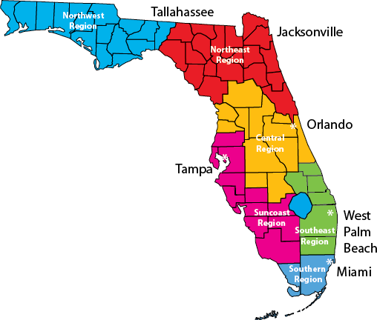
Northwest Region – Northwest.Intent@apdcares.org
Bay, Calhoun, Escambia, Franklin, Gadsden, Gulf, Holmes, Jackson, Jefferson, Leon, Liberty, Okaloosa, Santa Rosa, Wakulla, Walton, and Washington counties
Northeast Region – Northeast.Intent@apdcares.org
Alachua, Baker, Bradford, Clay, Columbia, Dixie, Duval, Flagler, Gilchrist, Hamilton, Lafayette, Levy, Madison, Nassau, Putnam, St. Johns, Suwannee, Taylor, Union, and Volusia counties
Central Region – Central.Intent@apdcares.org
Brevard, Citrus, Hardee, Hernando, Highlands, Lake, Marion, Orange, Osceola, Polk, Seminole, and Sumter counties
Suncoast Region – Suncoast.Intent@apdcares.org
Charlotte, Collier, DeSoto, Glades, Hendry, Hillsborough, Lee, Manatee, Pasco, Pinellas, and Sarasota counties
Southeast Region – Southeast.Intent@apdcares.org
Broward, Indian River, Martin, Okeechobee, Palm Beach, and St. Lucie counties
Southern Region – Southern.Intent@apdcares.org
Dade and Monroe counties
CDC+ Providers – felicia.jones@apdcares.org & apd.cdc.documents@apdcares.org

